

HydroDesktop

Version 1.1 Beta  
Quick Start Guide

**A guide to help you get started using this free and open source desktop application for discovering, accessing, and using hydrologic data.**

September 15, 2010

by:

Tim Whiteaker

Center for Research in Water Resources

The University of Texas at Austin

Distribution

HydroDesktop and all associated source code and documentation are available at the following website: <http://www.hydrodesktop.org/>.

HydroDesktop is provided free of charge under the Berkeley Software Distribution (BSD) license. Please see the following license information:

Copyright © 2010, Consortium of Universities for the Advancement of Hydrologic Science, Inc.

All rights reserved.

Redistribution and use in source and binary forms, with or without modification, are permitted provided that the following conditions are met:

* Redistributions of source code must retain the above copyright notice, this list of conditions and the following disclaimer.
* Redistributions in binary form must reproduce the above copyright notice, this list of conditions and the following disclaimer in the documentation and/or other materials provided with the distribution.
* Neither the name of Consortium of Universities for the Advancement of Hydrologic Science, Inc. nor the names of its contributors may be used to endorse or promote products derived from this software without specific prior written permission.

THIS SOFTWARE IS PROVIDED BY THE COPYRIGHT HOLDERS AND CONTRIBUTORS "AS IS" AND ANY EXPRESS OR IMPLIED WARRANTIES, INCLUDING, BUT NOT LIMITED TO, THE IMPLIED WARRANTIES OF MERCHANTABILITY AND FITNESS FOR A PARTICULAR PURPOSE ARE DISCLAIMED. IN NO EVENT SHALL THE COPYRIGHT OWNER OR CONTRIBUTORS BE LIABLE FOR ANY DIRECT, INDIRECT, INCIDENTAL, SPECIAL, EXEMPLARY, OR CONSEQUENTIAL DAMAGES (INCLUDING, BUT NOT LIMITED TO, PROCUREMENT OF SUBSTITUTE GOODS OR SERVICES; LOSS OF USE, DATA, OR PROFITS; OR BUSINESS INTERRUPTION) HOWEVER CAUSED AND ON ANY THEORY OF LIABILITY, WHETHER IN CONTRACT, STRICT LIABILITY, OR TORT (INCLUDING NEGLIGENCE OR OTHERWISE) ARISING IN ANY WAY OUT OF THE USE OF THIS SOFTWARE, EVEN IF ADVISED OF THE POSSIBILITY OF SUCH DAMAGE.

Disclaimers

Although much effort has been expended in the development and testing of HydroDesktop, errors and inadequacies may still occur. Users must make the final evaluation as to the usefulness of HydroDesktop for their application.

Funding for HydroDesktop and this document are provided by the Consortium of Universities for the Advancement of Hydrologic Science, Inc. (CUAHSI) under National Science Foundation Grant No. EAR-0622374. In addition, much input and feedback has been received from the CUAHSI Hydrologic Information System development team. Their contribution is acknowledged here.

Technical Support

For the latest downloads, documentation, discussion forum, and an issue tracker where bugs or feature requests can be posted, please use the HydroDesktop website at <http://www.hydrodesktop.org/>.

For additional support, please contact:

Yoori Choi

CUAHSI User Support Specialist

[ychoi@cuahsi.org](mailto:ychoi@cuahsi.org)

(339) 221-5402 office

(202) 641-4212 cell

Table of Contents

Introduction 1

Installation 2

Installing HydroDesktop for Windows (Mac/Linux coming soon) 2

Uninstalling HydroDesktop 2

Walkthrough - Downloading Streamflow Data 3

Opening HydroDesktop 3

Searching for Hydrologic Data 4

Viewing Downloaded Time Series 8

Exporting Data to a Text File 9

Summary 11

# Introduction

HydroDesktop is a free and open source Geographic Information Systems (GIS) application that helps you discover, use, and manage hydrologic time series data. The GIS components are built from the open source DotSpatial library, while the time series components utilize web services designed by the CUAHSI Hydrologic Information Systems (CUAHSI-HIS) project (see related links below). The result is a spatially-enabled system for downloading observational data describing our water environment.

**This document briefly introduces HydroDesktop and includes a simple walkthrough for downloading time series data.** If you’re dying to start some hands-on training, skip to the walkthrough section. Otherwise, stick around this intro section as we answer a few common questions about HydroDesktop.

**Who would use HydroDesktop?**

Basically, anyone who wants to download hydrologic time series data and use it. While the hydrologic research community is one target audience for HydroDesktop, we hope that students in science classes, educators, and professionals will also find HydroDesktop easy-to-use and helpful in their search for hydrologic data.

**Why use HydroDesktop?**

There is A LOT of hydrologic observations data freely available on the Internet. However, the plethora of websites and data formats makes it difficult to find, get, and use the data you want. CUAHSI-HIS changed all that by inventing a standard web service design called WaterOneFlow for accessing hydrologic data. This means that no matter from whom you’re getting data, the way you get the data is the same, as long as they are using WaterOneFlow. HydroDesktop is built from the ground up with the ability **to interact with WaterOneFlow web services, connecting your computer with data from the dozens of agencies and universities who are already publishing their data using this standard.**

**What are web services?**

Web services are like programs that you access on the Internet, which typically have one distinct “service” that they provide to you. WaterOneFlow is a web service whereby you provide a location, a variable of interest (e.g., streamflow), and a time period, and it returns a time series of data. The output format from WaterOneFlow is standard language called WaterML that includes both the time series data and also the metadata to fully describe the data. Confused at all of these new terms? It’s ok. HydroDesktop knows how to request data from a WaterOneFlow web service and translate the WaterML response into your local database so that you can get on with your analysis. It handles this web service mumbo jumbo so that you don’t have to!

**What operating system do I need?**

HydroDesktop is built for the .NET Framework 3.5 and Windows computers. However, the code is designed to be compatible with the Mono Framework to support Mac and Linux, although formal testing in this regard has yet to be done.

**Related Links:**

**HydroDesktop -** <http://www.hydrodesktop.org/>

**CUAHSI Hydrologic Information Systems -** <http://his.cuahsi.org/>

**DotSpatial -** <http://dotspatial.codeplex.com/>

# Installation

## Installing HydroDesktop for Windows (Mac/Linux coming soon)

Prior to using HydroDesktop, you must have the Microsoft .NET Framework 3.5 installed. This is free and was probably installed on your computer automatically with the latest Windows updates.

To install HydroDesktop:

1. Navigate to <http://www.hydrodesktop.org/>.
2. Click the **Download** link on the right side of the page to get the latest installer.

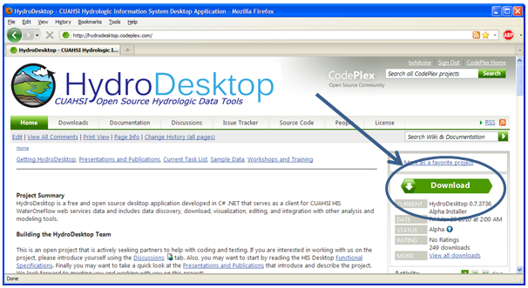

Figure HydroDesktop can be downloaded freely from <http://www.hydrodesktop.org>

1. Read the license and agree to it.
2. Save and run the installer. The installer will guide you through the rest.

**Note**Because HydroDesktop functionality continues to grow, the installer is periodically updated. Check back often for the latest version of HydroDesktop.

## Uninstalling HydroDesktop

HydroDesktop can be uninstalled from the standard Add or Remove Programs dialog. To uninstall HydroDesktop:

1. Open **Control Panel** (e.g., click Start | Control Panel).
2. In Control Panel, click **Add or Remove Programs** (Windows XP) or **Programs and Features** (Windows 7).
3. Select **HydroDesktop** in the list of installed programs, and click **Remove** (XP) or **Uninstall** (7).
4. Click to confirm removal of HydroDesktop from your system.

# Walkthrough - Downloading Streamflow Data

This section leads you through HydroDesktop’s most commonly-used functionality, namely: data search, visualization, and export. In this walkthrough, you’ll be working with streamflow data in Travis County, Texas, during the major flooding event in October, 1998. Once you have installed HydroDesktop, this walkthrough should take about 15 minutes to complete.

## Opening HydroDesktop

Let’s get familiar with HydroDesktop.

1. Open HydroDesktop (Start | All Programs | CUAHSI HIS | HydroDesktop | HydroDesktop).
2. Take a moment to explore the user interface.

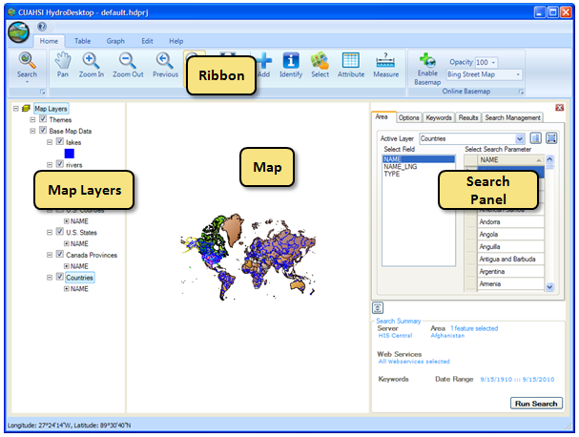

Figure HydroDesktop user interface

As you can see, HydroDesktop looks much like typical GIS applications. Indeed, it supports complex layer symbologies, adding your own shapefiles to the map, and even custom programmed tools and plugins. What sets HydroDesktop apart is the ability to query for hydrologic time series data.

## Searching for Hydrologic Data

When searching for data in HydroDesktop, you can specify the following filters: region of interest, time period of interest, and variables of interest (Figure 3). When the search results are returned, you can further filter the results and then choose which data you want to actually download and store as a theme in your database.

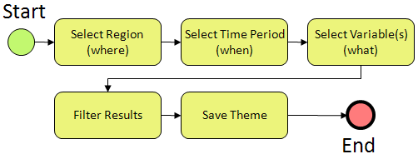

Figure Basic search workflow

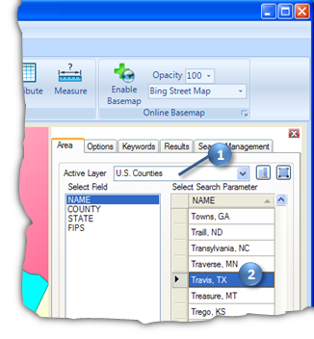Let’s practice this workflow by searching for streamflow data in Travis County during the 1998 Texas flood. First, you define the area to search.

Figure Choosing an area to search

1. In the S**earch Panel**, in the list of active layers, choose **U.S. Counties**. The map zooms to the extent of this layer while the Search Panel shows the fields in this layer.
2. Scroll through the county names until you find Travis. Click **Travis** to select it. The map zooms to Travis County, Texas, and highlights it in blue.

Next, you choose the time period for which you want to retrieve data. The 1998 Texas flood occurred in October, so you’ll search for data in that month.

1. In the Search Panel, click the **Options** tab.
2. Change the start date and end date to **October 1, 1998**, and **October 31, 1998**, respectively. You can do this by typing the numerical date (e.g., “10,” [RIGHT ARROW], “1,” [RIGHT ARROW], “1998”) or by clicking the down arrow next to the date to open a scrollable calendar.

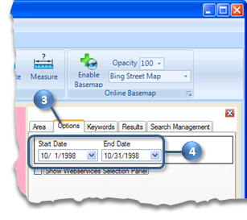

Figure Choosing a date range

**Tip**  
You could restrict your search to specific data sources on the Options tab, but for this walkthrough, we’ll use the default which is to search all data sources.

Now you’ll tell HydroDesktop what hydrologic parameter or variable you want. For this flood example, let’s get stream discharge.

1. In the Search Panel, click the **Keywords** tab.
2. Start typing **“discharge”** in the Keyword text box. Keywords that match what you have typed will appear on the left. These keywords are official names that CUAHSI has established for hydrologic parameters. Data from any source is mapped to this list in order to simplify the search process.
3. In the list of matching keywords, select **Discharge, stream**. The tree view on the right updates to show where the selected keyword fits within the CUAHSI Hydrologic Ontology.
4. Click the green **plus sign** to add the keyword to the list of keywords to search. Also notice that HydroDesktop keeps a search summary visible at the bottom of the Search Panel so that you can see the filters that you’ve specified for the search.
5. Click the **Run Search** button. This brings you to the Results tab as HydroDesktop searches for data. Behind the scenes, HydroDesktop is going out on the Internet to talk to HIS Central, where it asks for a summary of time series that match the criteria that you specified.

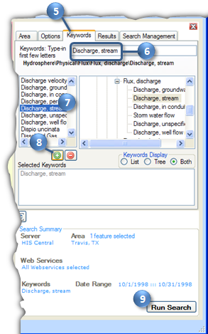

Figure Choosing a keyword and running the search

When the search finishes, you see a new map layer called **Search Results**, which is categorized by the source of the data. In this case, the two categories are NWISDV (US Geological Survey average daily values) and NWISIID (US Geological Survey instantaneous measurements). For this walkthrough, let’s just download average streamflow values.

1. In the **Search Panel**, scroll to the right until you see the **DataType column**.
2. Click **DataType** to sort by values in that column.
3. Click and drag the mouse in the table to select rows where the DataType is **Average**. This selects those rows in the table and also highlights those sites in the map in yellow.
4. In the Search Panel, type **“Texas Flood”** in the New Theme text box.
5. Click **Download Data**. HydroDesktop shows progress as it makes the data request for each time series.

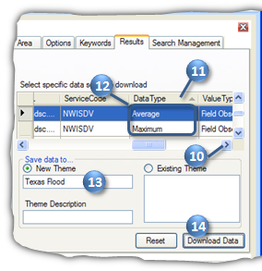

Figure Selecting time series to download

1. Click **OK** when the download is complete.

The new Texas Flood theme is added to the map, and can now be used with other HydroDesktop tools.

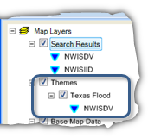

Figure Downloaded time series are displayed in the map as themes

Notice that in addition to downloading the time series data, HydroDesktop also created a map layer with an attribute table and other layer properties, including symbology (the map symbol) from the organization providing the data.

**Tip**Theme data are saved in the HydroDesktop database, which is a SQLite database in the same folder where HydroDesktop was installed.

## Viewing Downloaded Time Series

Now that you’ve downloaded some streamflow data, let’s have a look at the data in tabular and graph form.

1. In the Ribbon, click the **Table** tab.
2. Place a check next to **Colorado Rv at Austin** to see the streamflow values associated with that site.

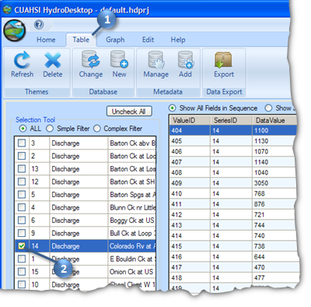

Figure Tabular view of time series

You can experiment with showing all fields in sequence or just values in parallel, to give you different views on the tabular data. You can also check additional boxes to show more than one time series at a time. However, for this walkthrough, let’s go ahead and plot a graph.

1. In the Ribbon, click the **Graph** tab.
2. Place a check next to **Onion Ck** to add that time series to the streamflow plot.

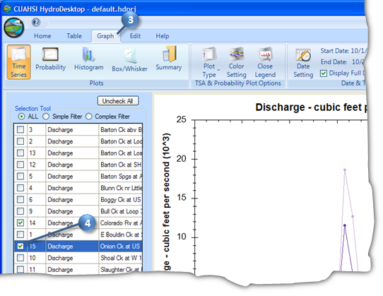

Figure Graph view of time series

1. Click on other plot types such as Probability and Histogram to see what they look like.

As you explore time series in HydroDesktop, you may find data that you want to export for use in other programs. In the next section, you’ll export all of the data for the Texas Flood theme to a text file.

## Exporting Data to a Text File

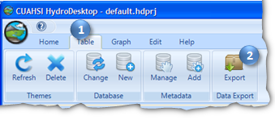There are several ways in which you can export data from HydroDesktop. In this part of the walkthrough, you will export the entire Texas Flood theme to a text file using the Data Export tool.

1. In the Ribbon, click the **Table** tab.
2. In the Data Export panel, click **Export**.

This tool exports all data in a theme to a delimited text file. This makes it easy for other programs to import data that you acquired using HydroDesktop. Peruse the options if you like, but we’ll use the defaults in this walkthrough.

Figure Entire themes can be exported to a single text file

1. Click **Browse** to tell HydroDesktop where to save the output. Choose a location and filename on your computer and click **Save**.
2. Click **Export Data**.

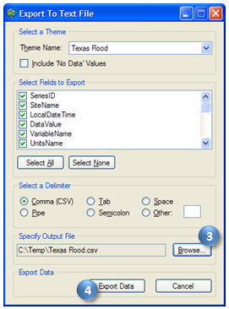

Figure Export To Text File dialog

1. When the tool has finished, navigate to the file on disk and open it to view the result.

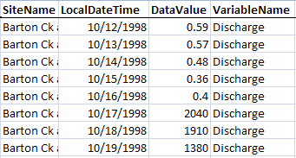

Figure Exported Texas Flood Data (shown in Microsoft Excel)

# Summary

In this walkthrough, you learned how to install and run HydroDesktop to search for time series data of a particular variable in a particular region of interest. You’ve seen how to visualize the result and export the data for use in other programs.

Now that you have a basic understanding of how HydroDesktop works, we encourage you to explore the other tools that HydroDesktop has to offer, and to take advantage of all the wonderful hydrologic data holdings now available to describe our water environment!